7th/8th Grade Math Syllabus 2018-2019
Brooks County Middle School

Contact/Class Information

School Email: bshackelford@brooks.k12.ga.us Phone: 229-588-2342

Room Number: 702 Planning Time: 8:00-9:45

Class Documents Email: bshackelford21@gmail.com

Class Webpage: http://msshackelford.com/

Facebook: www.facebook.com/bnshackelford
Instagram: www.instagram.com/shackelfordmath

Remind (homework, test, class announcements) Sign-up:
7th Grade Math Class: Text @21shack to 81010
8th Grade Math Class: Text @shack21 to 81010

Classroom Procedures
- Write your name and date on all assignments
  - Papers turned in without will get 5 pointed deducted.
- Students are expected to enter the room QUIETLY and begin on the assigned task.
- Place all bookbags under their desks and out of the aisles
- Take good notes and keep up with all assignments
- Make sure you are sitting correctly in your desk (chair not blocking traffic)
- Keep a well-organized notebook and binder by dates (descending order)
  - Tab 1: Writing About Math/BellRingers/Daily Reviews
  - Tab 2: Classroom Notes
  - Tab 3: Maintenance Sheets
  - Tab 4: Quizzes and Test
- Participate! Don’t be a spectator partner. Everyone has something to offer here.

Classroom Rules | Classroom Discipline Steps
- Come to class prepared daily and respect yourself and others.  - Adhere to School Policies *see handbook for clarification. | 1. Warning  2. One day Lunch Detention/Parent Contact/Student Conference  3. Two days Lunch Detention/Parent Contact  4. Parent Conference  5. Two days Lunch Detention/Parent Contact  6. Office Referral
Classroom Materials
- 3-Ring Binder (2 inch or bigger)
Calculator Example:
- Dividers
- Graph Paper
- Scientific Calculator TI-30XS
- Notebook Paper
- Pencils *no red pens, I usually grade in that color
- Colored Pencils/Markers
- Index Cards
- Headphones/Ear buds
- Highlighters
- Flash Drive
- Jacket (The classroom is frequently COLD!)

Optional: Expo Dry-Erase Markers, Expo Dry-Erase Erasers, Kleenex, Copy/Printer Paper(white or colored), Graph Paper, Notebook Paper, Pencils, Hand Sanitizer, Lotion, Clorox wipes, Sticky Notes

Summary of 8th Grade Math for the Year
Eighth grade mathematics is about
- formulating and reasoning about expressions and equations, including modeling and an association in bivariate date with a linear equation, and solving linear equations and systems of linear equations;
- grasping the concept of a function and using functions to describe quantitative relationships;
(3) analyzing two‐ and three‐dimensional space and figures using distance, angles, similarities, and congruence, and understating and applying the Pythagorean Theorem.

Georgia Standards of Excellence Curriculum Map
- 8/8-8/31: Unit 2A: Exponents
- 9/5-9/11: Unit 2B: Exponents, cont…
- 9/12-9/28: Unit 3: Geometric Applications of Exponents
- 10/1-10/19: Unit 4: Functions
- 10/22-11/16: Unit 5: Linear Functions
- 11/26-12/19: Unit 7: Solving Systems of Equations
- 1/8-1/11: Comprehensive Review
- 1/14-2/8: Unit 6: Linear Models and Tables
- 2/11 – 3/22: Unit 1: Transformations, Congruency and Similarities

Phrases or Words That ARE NOT ACCEPTABLE IN MY CLASS!!!
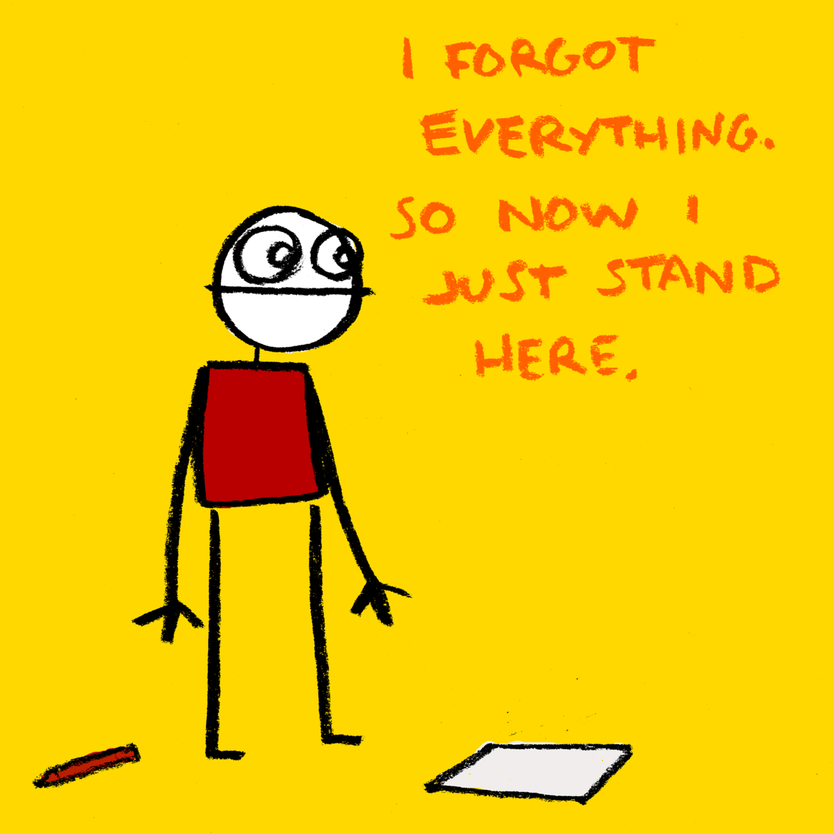

Student Responsibility When Working in Groups
- Make sense of problems and persevere in solving them
- Reason abstractly and quantitatively
  - “Think outside the box”
- Construct viable arguments and critique the reasoning of others
  - Challenge your partner
  - Explain
- Model with mathematics
  - Show your work
    - Create a table/chart/draw a picture
- Use appropriate tools strategically
  - Rulers, calculator, etc…
- Attend to precision
  - Label your answers
- Look for and make use of structure
- Look for and express regularity in repeated reasoning
****Use your inside voice and remain focus on “math”***

Homework (worth 10%)
- Students will be given a maintenance sheet (review over all concepts taught) at the start of every week.
  - This maintenance sheet will help you prepare for comprehensive test (test which focus on all concepts covered).
  - Your maintenance sheet is due on Thursday of that same week.
  - Your maintenance sheet will be graded.
  - Corrections can be made on missed problems, however, you must show your work
    - NO WORK! NO CREDIT!
- Signed grade reports *easy 100
  - Must be signed and dated by parent, with phone number listed in order to get homework grade

Daily Grades (worth 30%)
- Open Notebook Checks (5-10 questions based on notes, homework, and test)
- Quizzes
- Worksheets or Activities completed in class

Unit Test & Comprehensive Test (worth 60%)
- I missed a test, when can I make it up? If you miss a test or quiz, you will be expected to make it up the next day either in class or at my convenience. Beyond this, the test or quiz may not be made up and will result in a zero.

- 1st Semester Tentative Dates
  - August 31: Unit 2A Test
  - September 14: Unit 2B Test
  - September 28: Unit 3 Test
  - October 5: Comprehensive Test 1
  - October 19: Unit 4 Test
  - October 26: Comprehensive Test 2
  - November 16: Unit 5 Test
  - November 30: Comprehensive Test 3
  - December 19: Unit 7 Test
- 2nd Semester Tentative Dates
- February 1: Comprehensive Test 4
- February 8: Unit 6 Test
- March 14: Comprehensive Test 5
- March 22: Unit 1 Test
- May 3: Algebra 1 Pre-Exam
- GMAS April 16-May 1
Make-Up Policy
- What do I do if I’m absent? Ask your neighbor at an appropriate time. Get the missing materials from the missing w at an appropriate time during or after class. If you need clarification or have questions, ask Ms. Shackelford after class.

- When students are absent from class it is their responsibility to get assignments.
- All work missed (graded only) due to an absence must be made up within 3 school days after the student returns or that student will receive a zero (0). Parents will be notified of missing assignments.

Re-Test Policy
In order to re-test, students MUST come to tutoring sessions for 3 consecutive days during assigned time and bring back signed parent letter.

Tutoring
- Two types of tutoring
  - Volunteer – students sign up in advance
  - Mandatory – teacher creates list based on student grades and understanding.
  - Echoes is also encouraged
    - *parent notes/phone call is needed if student does not show
Promotion Criteria/Graduation Ceremony
- Purchase Black and White attire (8th Graders only)
- Pass all 4 academic classes (math, science, social studies, and language arts) with @ least 70 yearly average
- Pass connection classes with at least a 70 yearly average
- Pass the Georgia Milestones

